Experiment 8
Analyze Discrete and Continuous Probability Distributions Using R

PART B

(PART B: TO BE COMPLETED BY STUDENTS)
(Students must submit the soft copy as per following segments within two hours of the practical. The soft copy must be uploaded on the ERP or emailed to the concerned lab in charge faculties at the end of the practical in case the there is no ERP access available)
Roll No. C - 60 | Name: Avdhut Parish Madhavi
Class : SE – C | Batch : C2
Date of Experiment: | Date of Submission
Grade :

Observation : (Paste screenshots of each implementation steps given in the procedure)

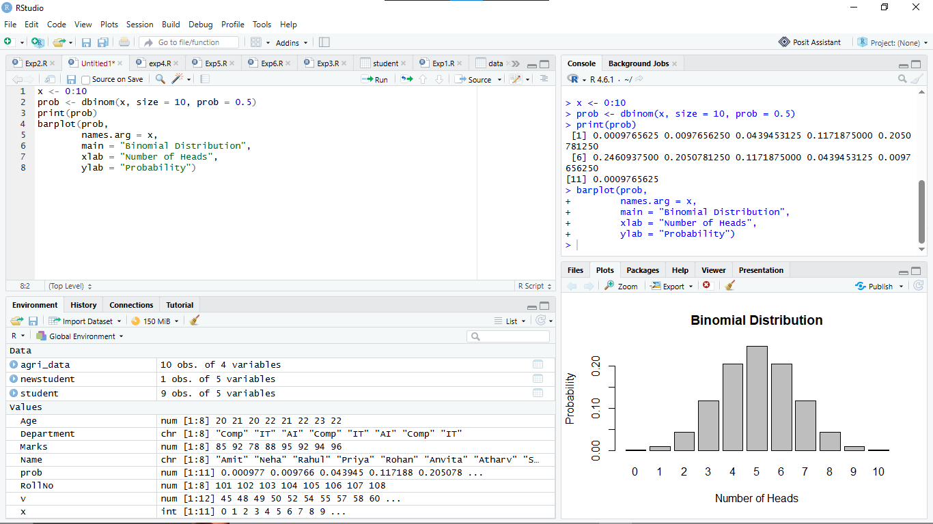

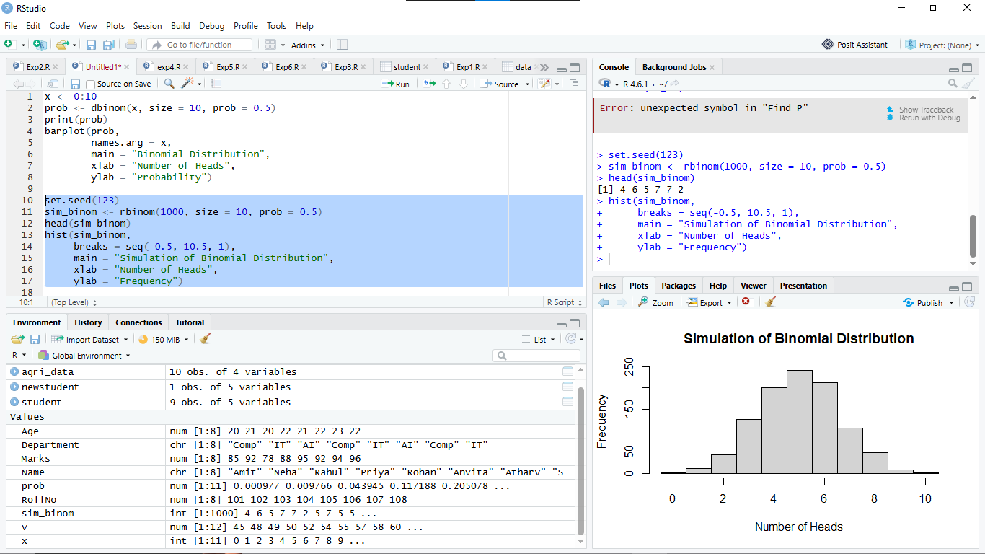

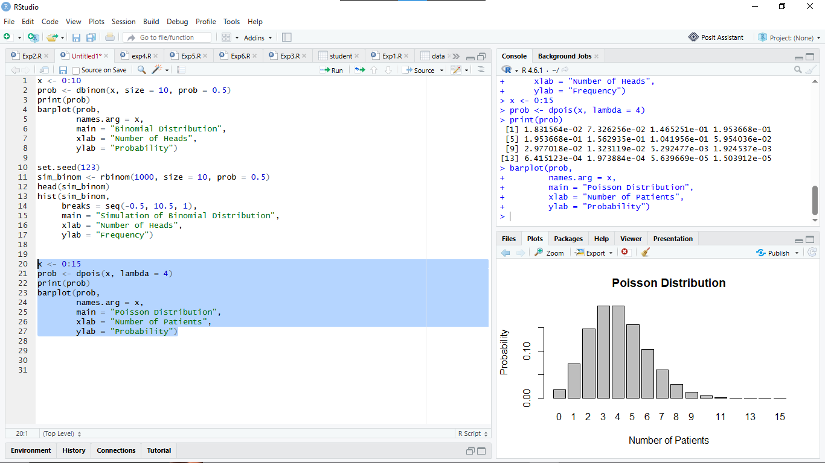

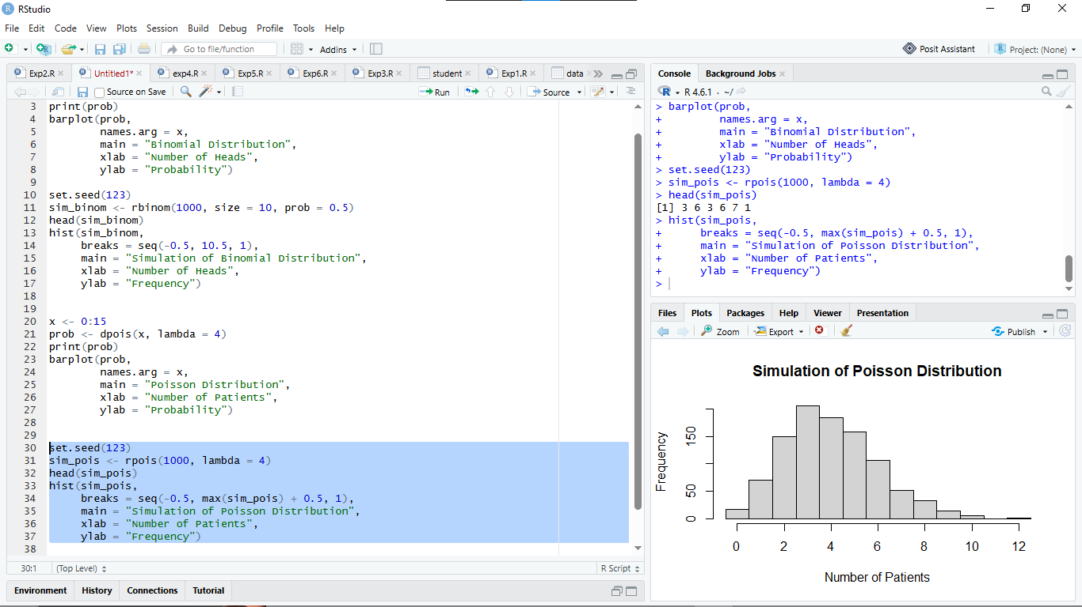

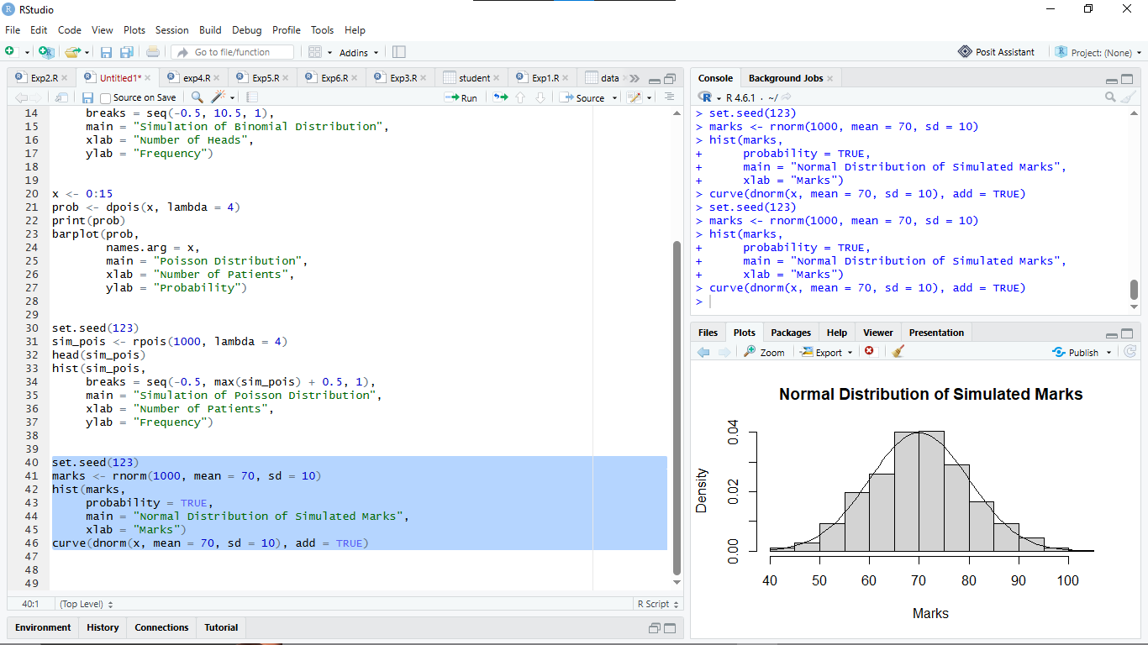

Observation Table: (Execute the procedure part and complete the observation table with results)

Experiment | Parameter | R Function | Observation / Result
Binomial | P(X = 6), n=10, p=0.5 | dbinom() | 0.2050781
Binomial | P(X ≤ 6) | pbinom() | 0.8281250
Poisson | P(X = 6), lambda=4 | dpois() | 0.1041956
Poisson | P(X ≤ 6) | ppois() | 0.8893260
Normal | P(X < 80), mean=70, sd=10 | pnorm() | 0.8413447
Normal | P(60 < X < 80) | pnorm() | 0.6826895
Normal | 95th percentile | qnorm() | 86.44854

2. R Programs for Observation Table

A. Binomial Distribution
1. Calculate P(X = 6) for n = 10 and p = 0.5.
R Program:
dbinom(6, size = 10, prob = 0.5)
Result: 0.2050781
2. Calculate P(X ≤ 6).
R Program:
pbinom(6, size = 10, prob = 0.5)
Result: 0.828125

B. Poisson Distribution
3. Calculate P(X = 6) for λ = 4.
R Program:
dpois(6, lambda = 4)
Result: 0.1041956
4. Calculate P(X ≤ 6).
R Program:
ppois(6, lambda = 4)
Result: 0.8893260

C. Normal Distribution
5. Calculate P(X < 80), given mean = 70 and standard deviation = 10.
R Program:
pnorm(80, mean = 70, sd = 10)
Result: 0.8413447
6. Calculate P(60 < X < 80).
R Program:
pnorm(80, mean = 70, sd = 10) -
pnorm(60, mean = 70, sd = 10)
Result: 0.6826895
7. Calculate the 95th percentile of the Normal distribution.
R Program:
qnorm(0.95, mean = 70, sd = 10)
Result: 86.44854

Result:
The discrete Binomial and Poisson distributions and the continuous Normal distribution were analyzed using R. Their probabilities, cumulative probabilities, and percentile values were calculated successfully using built-in statistical functions.
Conclusion:
The experiment helped us understand discrete and continuous probability distributions using R programming. We learned to calculate probabilities using dbinom(), pbinom(), dpois(), ppois(), and pnorm(), and calculate percentiles using qnorm(). These functions are useful in statistical analysis and real-world applications.

Curiosity Questions
Q1. What is a random variable?
A random variable is a variable that assigns a numerical value to each possible outcome of a random experiment. For example, the number of heads obtained when tossing a coin.
Q2. What is the difference between discrete and continuous random variables?
- Discrete random variable: Takes countable values, such as 0, 1, 2, 3.
- Continuous random variable: Takes any value within a given range, such as height, weight, or temperature.
Q3. When is the Binomial distribution used?
The Binomial distribution is used to calculate the probability of obtaining a certain number of successes in a fixed number of independent trials, with two possible outcomes and a constant probability of success.
Q4. What do n and p represent in a Binomial distribution?
- n: Total number of trials.
- p: Probability of success in each trial.
Q5. When is the Poisson distribution used?
The Poisson distribution is used to calculate the probability of a given number of events occurring in a fixed interval at an average rate, such as the number of calls received per hour.
Q6. What does lambda represent in the Poisson distribution?
Lambda (\(\lambda\)) represents the average number of events occurring in a fixed interval.
Q7. What is the difference between dbinom() and pbinom()?
- dbinom() calculates the probability of exactly a specified number of successes.
- pbinom() calculates the cumulative probability of obtaining at most a specified number of successes.
Q8. What is the purpose of rbinom()?
The rbinom() function generates random observations from a Binomial distribution. It is useful for simulating repeated random experiments.
Q9. What is the difference between pnorm() and dnorm()?
- pnorm() calculates the cumulative probability for a Normal distribution.
- dnorm() calculates the probability density at a specified value.
Q10. Why is probability at an exact point zero for a continuous random variable?
For a continuous random variable, probability is measured over an interval. A single point has zero width, so its probability is zero.
Q11. What does qnorm() calculate?
The qnorm() function calculates the quantile corresponding to a given cumulative probability in a Normal distribution. For example, it can calculate the 95th percentile.
Q12. Why is set.seed() used?
The set.seed() function ensures that random results can be reproduced when the same code is executed again.
Q13. How can a probability distribution be visualized in R?
A probability distribution can be visualized using graphs such as bar plots and histograms. Functions like barplot() and hist() are used to display the distribution.
Q14. Give one healthcare application of Poisson distribution.
The Poisson distribution can be used to model the number of patients arriving at a hospital emergency department per hour.
Q15. Give one real-world application of Normal distribution.
The Normal distribution can be used to model examination marks when they approximately follow a bell-shaped distribution.



